

**Data Technician**

|  |
| --- |
|  |

|  |
| --- |
| Name: |
| Course Date: |
|  |

**Table of contents**

Day 1: Task 1 2

Day 1: Task 2 2

Day 2: Task 1 3

Day 2: Task 2 3

Day 3: Task 1 4

Day 3: Task 2 5

Day 4: Task 1 6

Day 4: Task 2 7

Course Notes 7

Additional Information 8

# Day 1: Task 1

Please research the different versions of Tableau, compare and contrast them below and explain the limited functionality on ‘Tableau Public’.

|  |  |
| --- | --- |
| Different Tableau versions | Public is the free version  Technical specifications  Versions  https://www.tableau.com/en-gb/products/techspecs |

Tableau Prep

A modern approach to data preparation that makes it easier and faster to combine, shape and clean data for analysis.

Self-service, agentic data preparation

Tableau Prep provides a direct visual path to data preparation, making it simpler and faster to combine, shape and clean data for analysis. In just a few clicks, you can manage data prep chaos with scale.

OS requirements

Windows

Microsoft Windows 8/8.1, Windows 10 (x64), Windows 11

**Minimum system requirements**

* Intel Core i3 or AMD Ryzen 3 (dual core)
* 4 GB memory or larger
* 2 GB HDD free or larger
* CPUs must support SSE4.2 and POPCNT instruction sets

**Recommended requirements**

* Intel Core i7 or AMD Ryzen 7 (quad core)
* 16 GB memory or larger
* 2 GB SSD free or larger

**High-performance requirements**

* Intel Core i7 or AMD Ryzen 7 (8 Core)
* 32 GB memory or larger
* 2 GB SSD free or larger

[Learn more](https://www.tableau.com/en-gb/products/prep)

Tableau Desktop

### Explore, visualise and analyse all your data to uncover hidden insights and make smarter decisionSelf-service data modelling and analytics

Discover insights faster with powerful features that offer flexibility and control. From multi-fact relationships to custom themes, viz extensions and enhanced accessibility, Tableau Desktop puts you in charge, making it easy to turn data into impactful decisions.

Windows

Microsoft Windows 8/8.1, Windows 10 (x64), Windows 11

**Minimum system requirements**

* Intel Core i3 or AMD Ryzen 3 (dual core)
* 4 GB memory or larger
* 2 GB HDD free or larger
* CPUs must support SSE4.2 and POPCNT instruction sets

**Recommended requirements**

* Intel Core i7 or AMD Ryzen 7 (quad core)
* 16 GB memory or larger
* 2 GB SSD free or larger

Tableau Cloud

Experience a fully-hosted, cloud-based, AI-powered solution on the world's #1 analytics platform. Tableau Cloud is the new Tableau Online. Experience a fully hosted, cloud-based, enterprise-grade solution on the world's #1 analytics platform. As a fast, flexible, easy-to-use self-service platform designed to fit your enterprise architecture, it streamlines the power of data to make people faster and more confident decision makers from anywhere. Prepare your data, author, analyse, collaborate, publish and share in Tableau Cloud.

Tableau Pulse is now generally available on Tableau Cloud, empowering every employee with intelligent, personalised and contextual insights delivered in the flow of work.

Web browsers

* Chrome on Windows, Mac and Android
* Microsoft Edge on Windows
* Mozilla Firefox & Firefox ESR on Windows and Mac
* Apple Safari on Mac and iOS

Data sources

* Extracts of all data sources compatible with [Tableau Desktop](https://www.tableau.com/en-gb/products/techspecs#desktop). Note, extracts of multidimensional (cube) data sources are not available.
* Live connections to many data sources, both hosted in the cloud and on-premises via the Tableau Bridge client. See the [complete list here](https://help.tableau.com/current/online/en-gb/to_keep_data_fresh.htm).
* For more information on the differences between live connections and extracts in Tableau Cloud, [view the white paper](http://www.tableau.com/en-gb/learn/whitepapers/tableau-online-keeping-your-data-fresh?ref=wc&signin=33591447b7237d9ade1e5d4bb947d662).

Storage

* 1 terabyte

[Learn more](https://www.tableau.com/en-gb/products/cloud-bi)

Tableau Server

### Data to the people – responsibly

Extend the value of your data across your entire organisation with Tableau Server. Empower your business with the freedom to explore data in a trusted environment – without limiting it to predefined questions, wizards or chart types. Have the peace of mind that both your data and your analytics are governed, secure and accurate. IT organizations love Tableau for its ease of deployment, robust integration, simplicity of scalability and excellent reliability. You no longer have to choose between empowering the business or protecting your data – with Tableau, you can finally do both.

#### Web browsers

* Chrome on Windows, Mac and Android
* Microsoft Edge on Windows
* Mozilla Firefox & Firefox ESR on Windows and Mac
* Apple Safari on Mac and iOS
* Tableau Mobile iOS and Android Apps, available from the [Apple App Store](https://itunes.apple.com/us/app/tableau-mobile/id434633927) and [Google Play Store](https://play.google.com/store/apps/details?id=com.Tableau.TableauApp) respectively

Minimum requirements for installation

* Microsoft Windows Server 2016, 2019 (x64)
* Microsoft Windows Server 2022 (Tableau Server 2023.3.1+)
* For the latest release of Tableau Server: Alma Linux 8.x and 9.x, Amazon Linux 2023, CentOS Stream 8.x and 9.x, Oracle Linux 8.x and 9.x, Red Hat Enterprise Linux (RHEL) 8.3+ and 9.x, Rocky Linux 8.x and 9.x, Ubuntu 20.04 LTS, 22.04 LTS, and 24.04 LTS, all on x86-64 chipsets only (ARM-based processors are not supported).
* For a table showing Linux distro support across all supported Tableau Server versions, please see our [documentation](https://help.tableau.com/current/server-linux/en-gb/requ.htm#operating-system-requirements)
* CPUs must support SSE4.2 and POPCNT instruction sets

The minimum specifications are only suggested for prototyping and testing Tableau Server. The installer checks for the minimum system requirements and will not proceed on computers with less than these hardware minimums:

* 4 cores / 8v-CPU (ex.AWS)
* 64 GB system memory (initial node)
* 16 GB system memory (additional node in multi-node deployment)
* 15 GB minimum free disk space

Minimum recommendations for production

The minimum configuration recommended for production usage of Tableau Server is based on these hardware specifications:

* 8 physical cores / 16V-CPU (e.g. AWS)
* 128 GB system memory
* 50 GB minimum free disk space

| **Feature / Version** | **Tableau Public (Free)** | **Tableau Desktop (Paid)** | **Tableau Server / Tableau Cloud (Paid)** |
| --- | --- | --- | --- |
| **Purpose** | Create and share public visualizations | Advanced analytics and visualization creation | Centralized sharing, collaboration, and governance |
| **Data Source Connectivity** | Limited to files like Excel, CSV, Google Sheets, and web data connectors | Connects to over 80 data sources, including databases and cloud services | Accesses published data sources and workbooks from Tableau Desktop |
|  |  |  |  |
| **Feature / Version** | **Tableau Public (Free)** | **Tableau Desktop (Paid)** | **Tableau Server / Tableau Cloud (Paid)** |
| **Live Data Connections** | Limited (e.g., Google Sheets with daily refresh) | Full support for live connections and scheduled extracts | Supports live connections and scheduled refreshes |
| **Privacy & Security** | All visualizations are public and stored on Tableau Public servers | Allows saving workbooks locally and publishing to private servers or Tableau Cloud | Offers enterprise-level security, user permissions, and governance |
| **Offline Access** | Not available | Full offline functionality | Not applicable; designed for online access |
| **Advanced Features** | Basic visualization tools | Advanced analytics, calculations, and visualization options | Facilitates collaboration, version control, and integration with enterprise systems |
| **Collaboration Tools** | Limited to public sharing | Share via Tableau Server, Tableau Cloud, or packaged workbooks | Enables user collaboration, commenting, and subscriptions |
| **Cost** | Free | Requires a paid license | Requires a paid license |
|  |  |  |  |

**Limitations of Tableau Public**

While Tableau Public is a valuable tool for learning and sharing visualizations, it has several limitations:

* **Public Visibility**: All workbooks are publicly accessible; private data cannot be kept confidential.
* **Data Source Restrictions**: Cannot connect to many databases or cloud services; limited to certain file types and web connectors.
* **Data Refresh Limitations**: Supports limited data refresh options, such as daily updates for Google Sheets.
* **Feature Constraints**: Lacks advanced analytics features like complex calculations, forecasting, and sophisticated dashboard functionalities.
* **No Offline Work**: Requires an internet connection; cannot work offline.

These constraints make Tableau Public more suitable for personal projects, learning, and sharing non-sensitive data publicly.

# Day 1: Task 2

Using the *EMSI_JobChange_UK* dataset, create your own dashboard, I want to see a bar chart showing percentage change and a UK based map showing the key city locations impacted.

|  |  |
| --- | --- |
| Paste your print screen here | Fig 1 My the EMSI_JobChange_UK dataset Dashboard |
|  | Fig 2 |

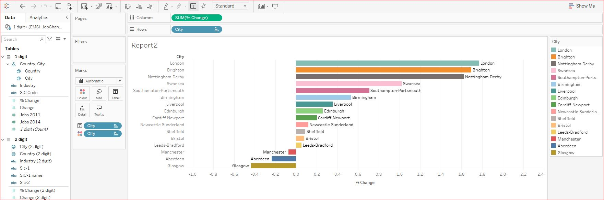

Fig 3 Horizontal Bar chart

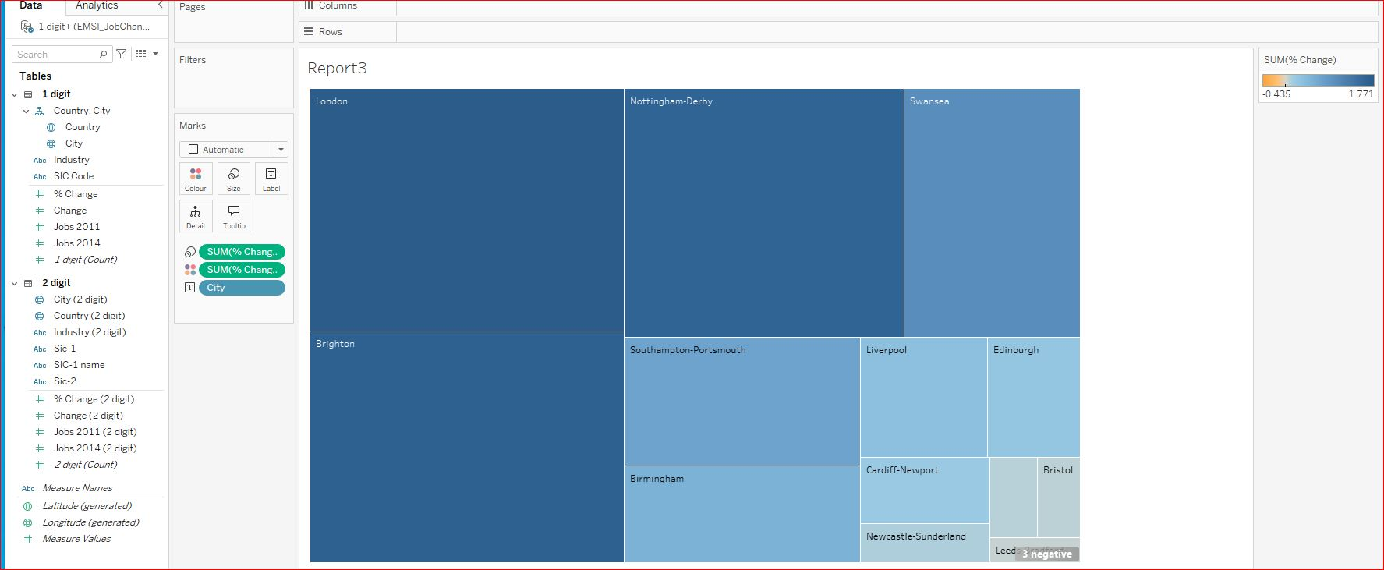

Fig 4

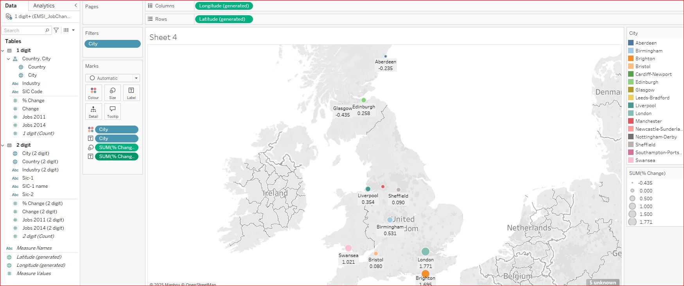

Fig 5. UK based map showing the key city locations impacted.

# Day 2: Task 1

Using the Spotify data set, conduct an analysis to find trends and key information that could be used by an organisation for future projects.

There is no set scope for the analysis, simply to find trends and document them below:

|  |  |
| --- | --- |
| Paste your print screens here | Fig 1 Popularity Trend Line    Fig 10 Top Genres By 10 Average Energy |

|  |  |
| --- | --- |
| What did you find? |  |

# Day 2: Task 2

Using the Health, conduct an analysis to find trends and key information that could be used by an organisation for future support.

There is no set scope for the analysis, simply to find trends and document them below.

* Data can be lifesaving and is being used more within the NHS, reflect on how this data could support decision making for the NHS.

|  |  |
| --- | --- |
| Paste your print screens here |  |
| What did you find and any reflections on how the NHS could use this? |  |

# Day 3: Task 1

Please complete Lab 1 ‘Get Data in Power Bi Desktop’. Once complete, paste a print screen below and in the collaboration board.

“Teaching is the best way to learn, so please listen out for support requests from the class and we’ll work through the challenges together”

|  |  |
| --- | --- |
| Paste your completed lab here |  |

# Day 3: Task 2

Please complete Lab 2 ‘Load Transformed Data in Power BI Desktop’. Once complete, paste a print screen below and in the collaboration board.

“Teaching is the best way to learn, so please listen out for support requests from the class and we’ll work through the challenges together”

|  |  |
| --- | --- |
| Paste your completed lab here |  |

# Day 4: Task 1

Please complete Lab 6 ‘Design a Report in Power BI Desktop’. Once complete, paste a print screen below and in the collaboration board.

“Teaching is the best way to learn, so please listen out for support requests from the class and we’ll work through the challenges together”

|  |  |
| --- | --- |
| Paste your completed lab here |  |

# Day 4: Task 2

Please complete Lab 10 ‘Create a Power BI Dashboard’. Once complete, paste a print screen below and in the collaboration board.

“Teaching is the best way to learn, so please listen out for support requests from the class and we’ll work through the challenges together”

|  |  |
| --- | --- |
| Paste your completed lab here |  |

|  |
| --- |
| **Course Notes** |

It is recommended to take notes from the course, use the space below to do so, or use the revision guide shared with the class.

We have included a range of additional links to further resources and information that you may find useful, these can be found within your revision guide.

**END OF WORKBOOK**

**Please check through your work thoroughly before submitting and update the table of contents if required.**

**Please send your completed work booklet to your trainer.**

|  |
| --- |
| **Information** |